-Draft-

Study Scope for the 2020- 2021 NorthernGrid Planning Cycle
Member Planning Committee Approval Date: July 22, 2020

Executive Summary
This Study Scope outlines the NorthernGrid 2020-2021 regional transmission planning process, as required under FERC Orders No. 890 and 1000, in accordance with each Enrolled Party’s Open Access Tariff (OATT) Attachment K – Regional Planning Process and NorthernGrid Planning Agreement.
The NorthernGrid Regional Transmission Plan evaluates whether transmission needs within the NorthernGrid may be satisfied by regional and/or interregional transmission projects. The NorthernGrid Regional Transmission Plan provides valuable regional insight and information for all stakeholders, including developers, to consider and use in their respective decision-making processes.

The study plan for NorthernGrid’s 2020-21 Regional Transmission Plan was developed using the following process:

- Identify the Baseline Projects of Enrolled Parties. Baseline Projects are the transmission projects included in the Enrolled Parties’ Local Transmission Plans. In future regional planning cycles, the Baseline Projects will also comprise projects included in the prior Regional Transmission Plan that will be reevaluated (there will be no reevaluation for this first Regional Transmission Plan).
- Evaluate combinations of the Enrolled Parties Baseline Projects and Alternative Projects to identify whether there may be a combination that effectively satisfies all Enrolled Party Needs.
- Use Power flow and dynamic analysis techniques to determine if the modeled transmission system topology meets the system reliability performance requirements and transmission needs.
- Select the Regional Combination that effectively satisfies all Enrolled Party Needs into NorthernGrid’s Regional Transmission Plan.

Overview of Key Findings:
Regional Summary of Needs
The regional needs were sourced from member data submissions, including load forecasts, resource additions and retirements, projected transmission, and public policy requirements. Data submissions were received from NorthernGrid’s 13 members, comprised of Avista (AVA), Bonneville Power Administration (BPA), Chelan PUD (CHPD), Grant County PUD (GCPD), Idaho Power Company (IPC), Montana Alberta Tie Line (MATL), NorthWestern Energy (NWMT), PacifiCorp East and West (PACE and PACW), Portland General Electric (PGE), Puget Sound Energy (PSE), Seattle City Light (SCL), Snohomish PUD (SNPD) and Tacoma Power (TPWR).

- Load Forecast – Results indicate an average of 0.5 percent annualized load growth for the entire membership between 2024-2030.
  - The range varies significantly between members from declining load of -0.3 to highest growth of 2 percent
  - The 2030 NorthernGrid member load peak is forecast to reach 44,225 MW and 43,646 MW winter and summer, respectively.
- Generation Retirements - Members reported 6,000 MW of retirements.
- Resource Additions - 13,390 MW of renewable resources are replacing the generation retirements.
- Proposed Member Transmission - Members are proposing 54 new and upgrade transmission line projects, primarily for local load service and increased reliability.
- Proposed Regional Transmission - There are four proposed regional transmission projects, including Antelope – Goshen, Boardman to Hemingway, Gateway South and Gateway West.
- Proposed Regional Non-incumbent and Interregional - There are five projects proposed, including Cascade Renewable Transmission System, Cross-Tie, SWIP North, Transwest Express, and Loco Falls Greenline.

Case Analysis
The NorthernGrid Regional Transmission Plan will assess the existing system and committed projects along with combinations of planned and proposed transmission and resource changes for their ability to reliably serve the annual variations in 2030 load and generation dispatch conditions.

Initial analysis of the data submissions indicates that the NorthernGrid region experiences peak loading conditions during the winter and summer. Therefore, a heavy winter and heavy summer condition will be represented. Additionally, high transmission transfers can occur during the shoulder months. A light spring and heavy fall condition will also be evaluated.
Cost Allocation
TransCanyon LLC and Great Basin Transmission, LLC were pre-qualified by NTTG during 2019 for the 2020-21 Regional Transmission Planning cycle. The NorthernGrid Enrolled Parties proposed, and FERC accepted, that their qualification status be accepted by NorthernGrid during this planning cycle. PowerBridge submitted developer qualification information which was reviewed by the Cost Allocation Task Force resulting in the approval of PowerBridge as a Qualified Developer for this planning cycle.

Table of Contents
Contents
Executive Summary 2
Overview of Key Findings: 2
Table of Contents 3
1. Introduction and Purpose Statement 5
1.1. Regional Transmission Plan Development 6
1.1.1. Regional Transmission Plan Development Process Overview 6
1.1.2. General Schedule and Deliverables 6
1.1.3. Stakeholder Engagement 7
1.1.4. Next Steps 7
2. Regional Summary of Needs 7
2.1.1. Data Submission Results 7
Figure 3: Summary of Member Data Submissions 9
2.1.2. Local Transmission Plans Summary 11
2.1.3. Loads Summary 11
2.1.4. Resources Summary 2020-2030 14
2.1.4 Transmission Service Obligations 18
2.1.5. Enrolled Parties Needs 19
2.1.6. Member Regional Transmission Projects 19
2.1.7. Public Policy Requirements Summary 21
2.1.7.1. Approach 21
2.1.7.2. Key Assumptions 21
2.1.7.3. Key Findings 22
2.1.8. Potential Areas of Regional Coordination 22
3. Non-Incumbent Transmission Projects 22
4. Case Analysis 24
4.1.1. Methodology and Assumptions Overview 24
4.1.2. Analysis Objectives 25
4.1.3. Conditions to Represent 25
4.1.4. WECC Power Flow Cases 25
4.1.4.1. WECC Power Flow Cases Summaries 25
4.1.5. Case Checking and Tuning 26
4.1.6. Types of Analysis 26
4.1.6.1. Performance Criteria 26
4.1.6.2. Contingencies Included 27
4.1.7. Production Cost Model Cases Summary 27
4.1.8. Identification of Other Cases Needed 27
4.1.9. Evaluation of Regional Transmission Project Combinations 27
5. Impacts on Neighboring Regions 28
6. Cost Allocation 28
A. Introduction 28
B. Qualified Developers 28
C. Benefits and Beneficiary Analysis 28
Appendix A 29
Data Tables 29
Appendix B 41
Appendix C 43

Introduction and Purpose Statement
The objective of the transmission planning study is to produce the NorthernGrid Regional Transmission Plan, through the evaluation and selection of regional and interregional projects that effectively satisfies all the transmission needs within the NorthernGrid region. The regional needs were sourced from member data submissions, including load forecasts, resource additions and retirements, projected transmission, and public policy requirements.
NorthernGrid is comprised of three primary committees as shown on Figure 1 below. Summary of committees:
- The Member Committee (MC) is composed of NorthernGrid member representatives. The MC is responsible for membership approval, budget development and approval, and vendor management.
- The Member Planning Committee (MPC) is composed of transmission planner representatives from all NorthernGrid members. The MPC is responsible for development of the regional transmission plan.
- The Enrolled Parties Planning Committee is composed of Federal Energy Regulatory Commission (FERC) jurisdictional utilities. Collectively these members are responsible for regional transmission planning compliance. There are two sub-committees of this primary committee:
  - The Enrolled Parties and States Committee (EPSC) is responsible for state engagement in the regional transmission planning process.
  - The Cost Allocation Task Force (CATF) is composed of enrolled parties and states representatives and is responsible for cost allocation compliance.

Figure 1: NorthernGrid Committee Structure Overview

Regional Transmission Plan Development

Regional Transmission Plan Development Process Overview
NorthernGrid began the process to develop a regional transmission plan by requesting members to submit data pertaining to forecasted loads, resource additions and retirements, transmission additions and upgrades, and public policy requirements. The plan spans the 2020- 2030 time period.
The regional plan will be developed over the course of two years, beginning March 31, 2020 and ending December 31, 2021. A summary of the key steps in Year 1 and Year 2 is included below. The dates shown in the table are approximate and subject to change.

General Schedule and Deliverables

Stakeholder Engagement
Stakeholders are invited to participate in the public meetings and comment periods. They will also have active involvement in the development of the regional transmission plan. The first period for stakeholder comments begins with the publishing of the Draft Study Scope on July 22, 2020.
Comment
Comment
Comment
Data
Projects
Enrolled Parties and States Committee (EPSC)
Stakeholders, Contribute to Scope, Comment on Plan
Enrolled Parties Planning Committee
Facilitate Compliance, Determine Eligibility for Cost Allocation
Cost Allocation Task Force
Facilitate Compliance Prequalification, Benefit and Cost Allocation
Member Committee
Membership, Budget, Vendor Management
Member Planning Committee
Stakeholders Coordination, Study Scope, Transmission Plan Approval

Next Steps
A Stakeholder meeting is scheduled for July 29th following the posting of the Draft Study Scope. The Stakeholder meeting opens a 15-day public review and comment period. This posting also opens a 60-day project submission window. Analysis begins once the Study Scope is approved by the MPC. The analysis is forecasted to encompass the second half of 2020 and culminate with the posting of a Draft Regional Transmission Plan around January 15, 2021. The second year allows for data updates, Interregional Transmission Project coordination, Cost Allocation analysis and publication of the Final Regional Transmission Plan before December 31, 2021.

Regional Summary of Needs

Data Submission Results
This section summarizes the data submission results that NorthernGrid received from its 13 members. The NorthernGrid is comprised of Avista (AVA), Bonneville Power Administration (BPA), Chelan PUD (CHPD), Grant County PUD (GCPD), Idaho Power Company (IPC), Montana Alberta Tie Line (MATL), NorthWestern Energy (NWMT), PacifiCorp East and West (PACE and PACW), Portland General Electric (PGE), Puget Sound Energy (PSE), Seattle City Light (SCL), Snohomish PUD (SNPD), Tacoma Power (TPWR). The member Balancing Authority Areas are illustrated in Figure 2 below.

Figure 2: NorthernGrid Member Balancing Authority Areas
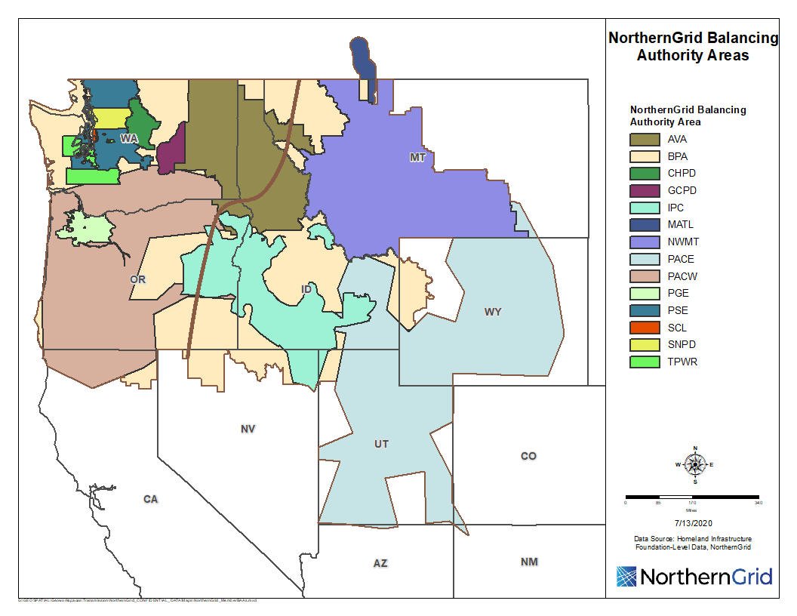
The NorthernGrid members that are registered as Balancing Authority Areas are required to submit a ten-year load and resource forecast to the Western Electricity Coordinating Council (WECC) annually. This forecast includes identification of forecasted generation resources and transmission facilities. The NorthernGrid leverages this submission for the biennial regional transmission plan. Each member submitted their data and the NorthernGrid summarized the data pertinent to the NorthernGrid region: load, generation resource retirements, generation resource additions, and 230 kV and above and 115 kV that members deem relevant transmission additions. A summary of each member’s data submission is shown in Figure 3. In the graphic, each member four-square displays (beginning in the upper left quadrant and continuing clockwise) their local planning data submission for load growth, generation resource retirements and additions along with local and regional transmission projects. Additionally, the center four-square is the regional perspective (summation) for load growth, generation resource retirements and additions, and transmission additions deemed to have regional impact.

Figure 3: Summary of Member Data Submissions

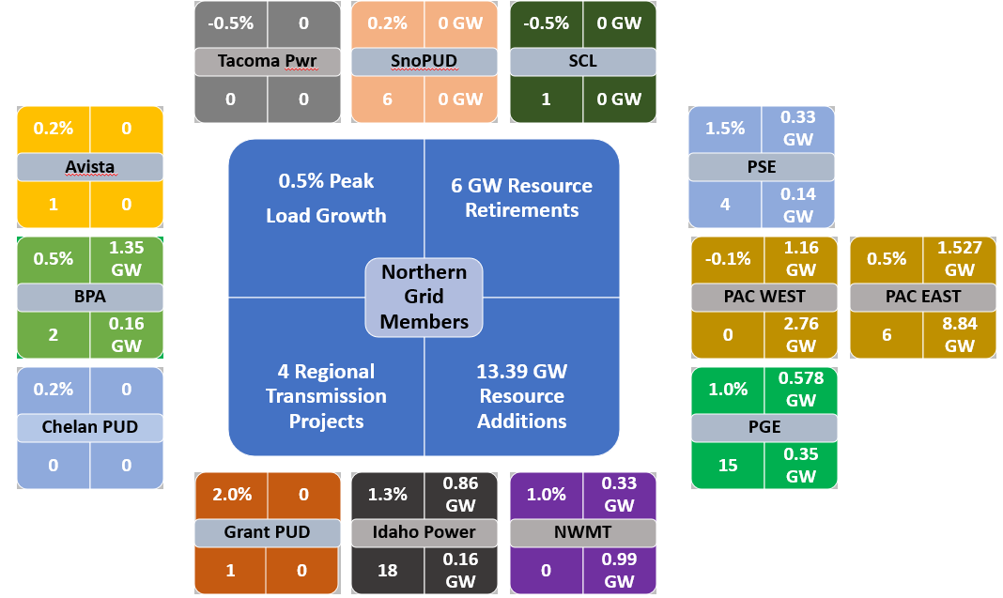

The NorthernGrid regional transmission planning area spans the Pacific Northwest and Intermountain states with two geographic areas. This area contains 973,582 square miles and 51,656 miles of transmission lines. These areas have different peak load characteristics as detailed in the loads section later in the Study Scope. For the purposes of the regional transmission plan data analysis and study case development, the NorthernGrid MPC divided the study area into the Pacific Northwest (NG-PNW) and Intermountain states (NG-IM) areas as shown by the two shaded areas in Figure 4.

Figure 4: NorthernGrid Existing Transmission System with Pacific Northwest and Intermountain West Sub-Areas
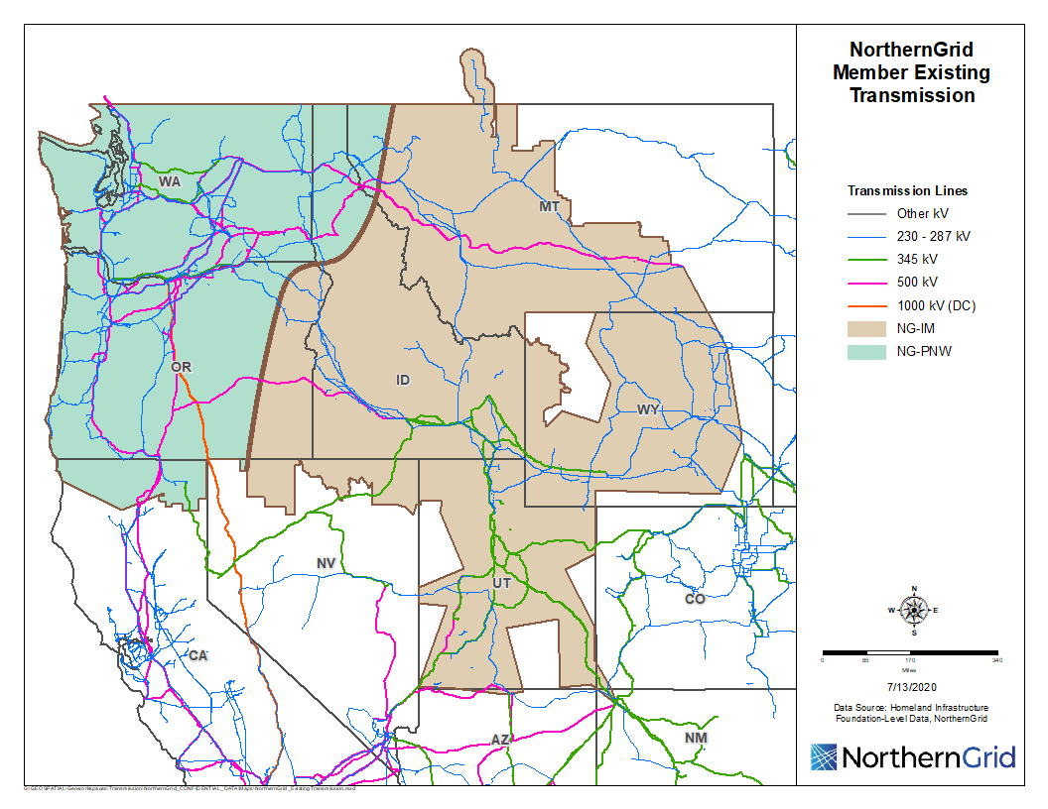

Resource Additions and Retirements Summary
The 13,390 MW of generation resource additions are forecasted during the planning horizon with 9,985 MW in the NG-IM and 3,405 MW in the NG-PNW. There are also 6,000 MW of generation resources retirements planned, with most occurring in the NG-IM area.
Projected Transmission Summary
There are four regional transmission projects identified in the data submissions. They are the Antelope to Goshen, Boardman to Hemingway, Gateway South, and Gateway West.

Local Transmission Plans Summary

The NorthernGrid members have projected the need for 54 new and upgraded transmission system projects in the local transmission planning processes. Most of these projects support local load service and reliability. Based on the geographic diversity and short length of these projects, the MPC’s initial review did not identify many opportunities for regional collaboration on these projects.

Please see the appendix for a detailed data table of all the projected transmission projects submitted by NorthernGrid members.

Loads Summary
The 2030 NorthernGrid member load peak is forecast to reach 44,225 MW and 43,646 MW winter and summer, respectively. The NG-PNW area peaks in the winter at 32,014 MW and the NG-IM area peaks in the summer at 16,083 MW. Table 1 summarizes the Member peak loads months within the four seasons.

Key Findings:
- During the winter season, both NG-PNW and NG-IM have a peak in January, with gray shading.
- The spring, summer and fall have differing months when the peak load occurs for the two sub-areas, with gray shading. The winter, spring and fall peak is driven by the dominant NG-PNW cold weather load. Conversely, the summer season NorthernGrid peak load occurs along with the high NG-IM irrigation and air conditioning load.
- Modeling the January winter peak and a July summer peak will provide the NorthernGrid Members the ability to analyze their peak loading conditions.
- The spring and fall loading conditions between the two areas differ significantly with the NG-PNW having larger variation due to early and late cold winter weather conditions. The modeling for these seasons may better be determined by variation in hydro, wind and solar resource output conditions.
Figure 5 and Figure 6 graphically illustrate by BA the annual winter and annual summer peak load and peak load growth between 2024-2030. Additional NorthernGrid region winter and summer peak load is geographically represented in substation load bus heat maps in Figures A1 and A2 in Appendix A.

Figure 5: Annual Winter Load Growth
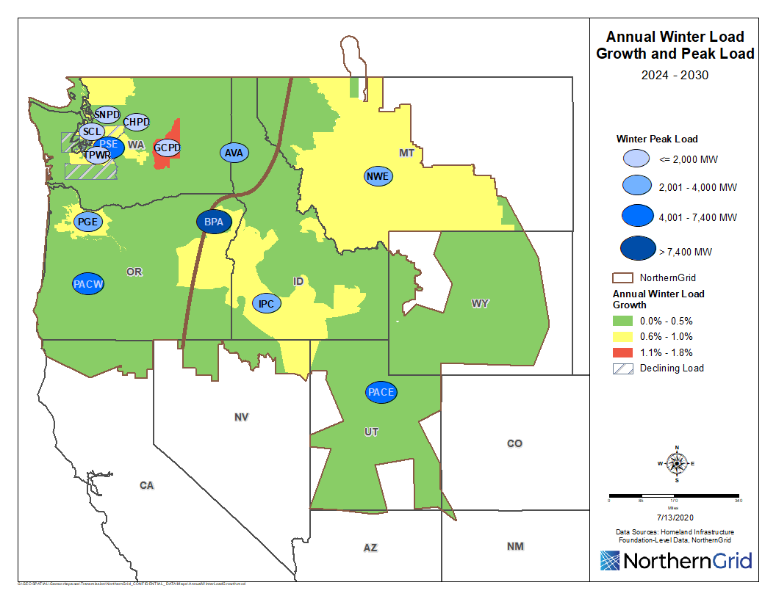

Figure 6: Annual Summer Load Growth
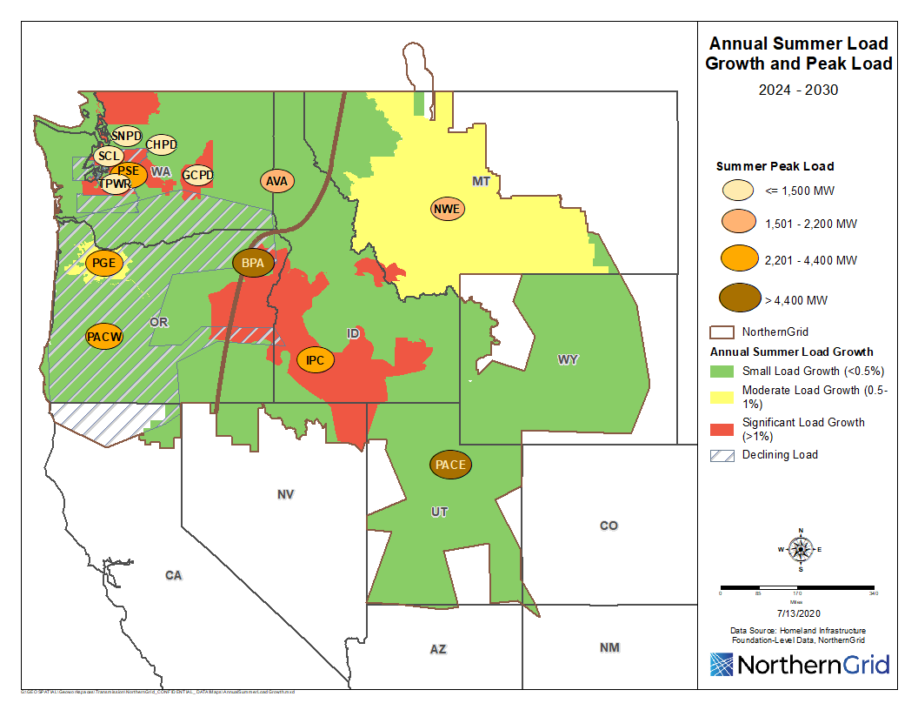
A majority of the NorthernGrid area is forecasted to have minimal peak load growth. Moderate winter and summer peak loads are predicted by PGE. However, the Puget Sound area outside of the major population centers of Seattle and Tacoma anticipate moderate winter and high summer load growth driven by increased air conditioning installations. GCPD projects high growth through all seasons due to data centers. Similarly, NWMT forecasts moderate peak load growth in both winter and summer. Finally, IPC is expecting moderate winter and high summer peak load growth as its population continues to expand.

Key Findings:
- There is an average of .4% to .5% peak load growth for the entire NorthernGrid membership.
- GCPD is the only member expecting some significant growth at 1.6 up to 1.8% from 2024-2030
- A few NorthernGrid members are at 0.65 to 0.7% growth while the others have forecasted low load growth.
- PACW has noted declining load growth for 2024 out to 2030.

Please see the appendix for a detailed data table with information about each member’s annual winter and summer peak load growth forecasts.
Existing and planned demand response resources summary
The demand response for the period is forecasted to remain the same with IPC providing 390 MW and PACE 450 MW. PacifiCorp has an additional 504 MW of interruptible demand and TPWR has 64 MW.

Resources Summary 2020-2030
As stated in the introduction of the Study Scope, there are 13.4 GW of resources being developed within the NorthernGrid region. About 11.6 GW are planned by PacifiCorp along with nearly 1.5 GW of batteries. More than 75 percent of resource development is forecast for the NG-IM area.
The resource additions reflected on the following map and in Appendix A Table A2 are preliminary in nature, representative only and are subject to change. Each future resource location modeling is based on current preliminary information that is subject to change. All future resources are based on member resource planning processes. The Enrolled Parties determine resource additions through an Integrated Resource Planning (IRP) process under state mandate. Many of the resource additions presented are based on the existing IRP preferred portfolio which may change during subsequent biennial planning cycles. IRP resource additions are subject to procurement request for proposals which may change the final resource location and in-service date.

Figure 7a represents forecasted generation resource additions by county location and fuel type and figure 7b shows generation resource additions year-over-year between 2020-2030.

Figure 7a: Resource Additions 2020-2030

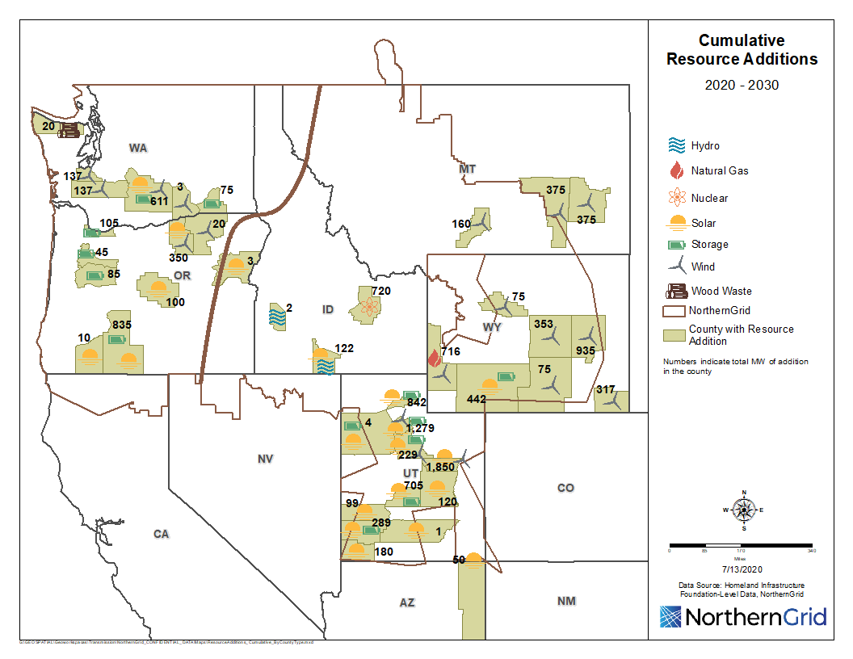

Figure 7b: Resource Additions by Fuel Type Year-Over-Year Between 2020 – 2030 and Cumulative

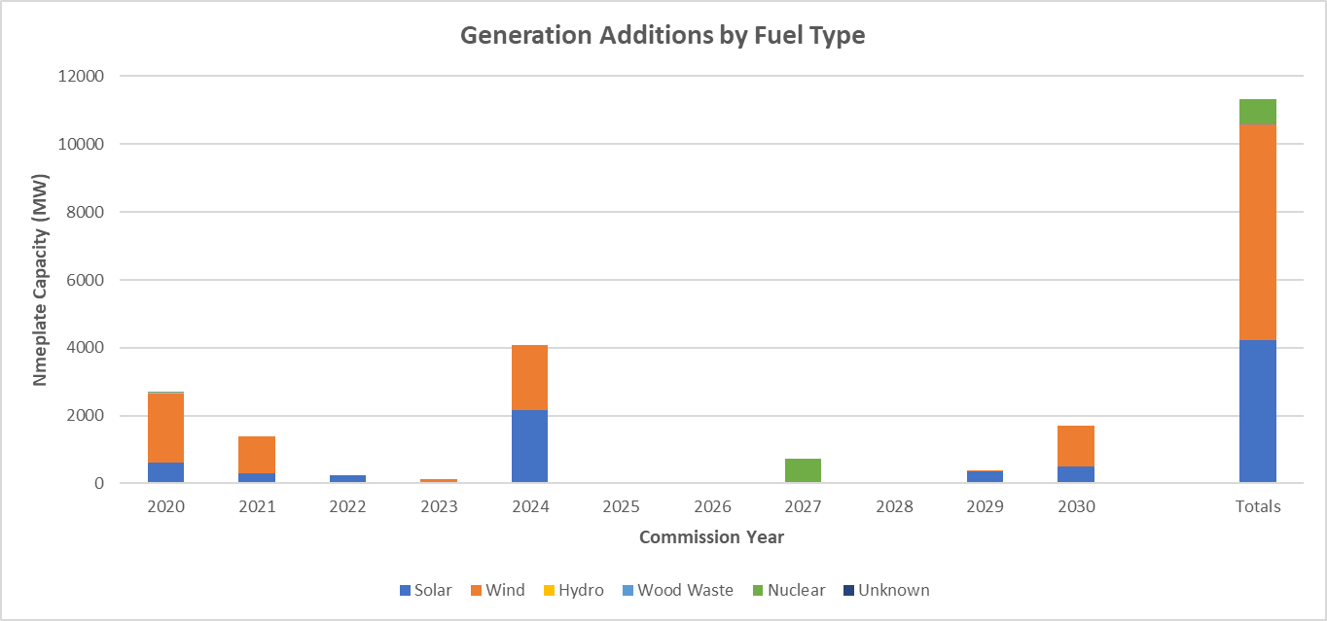
The Montana and Wyoming wind models typically simulate high output during the hours when the NorthernGrid members experience their daily system peak conditions. Similarly, simulations for NG-IM solar produce output at fifty percent, or more, of rated output when NorthernGrid member load reaches peak conditions. Additionally, there are forecasts for multiple energy storage project additions.
There are 6,000 MW of retirements planned between 2020 - 2030. Figure 8a represents forecasted generation resource retirements by county location and fuel type and figure 8b shows forecasted generation resource retirements year-over-year between 2020-2030. The bars in Figure8b represent a per plant per unit retirement and the line illustrates the cumulative retirements.

Figure 8a: Resource Retirements 2020-2030
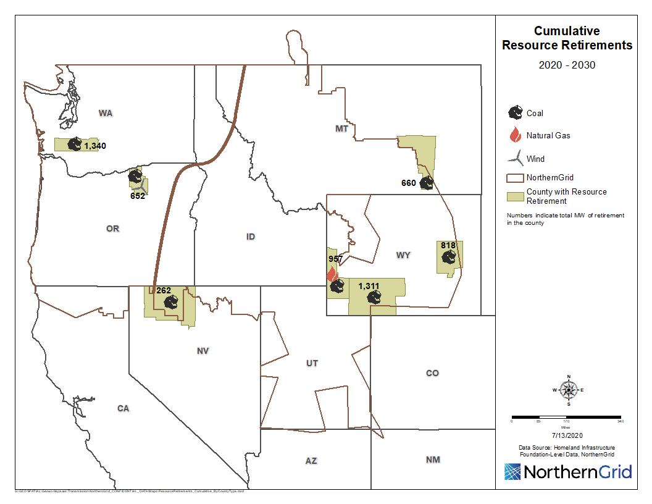
Please see the appendix for detailed data tables with information about the proposed resources additions and retirements, fuel type, county locations, and commission year.

Figure 8b: Resource Retirements 2020-2030

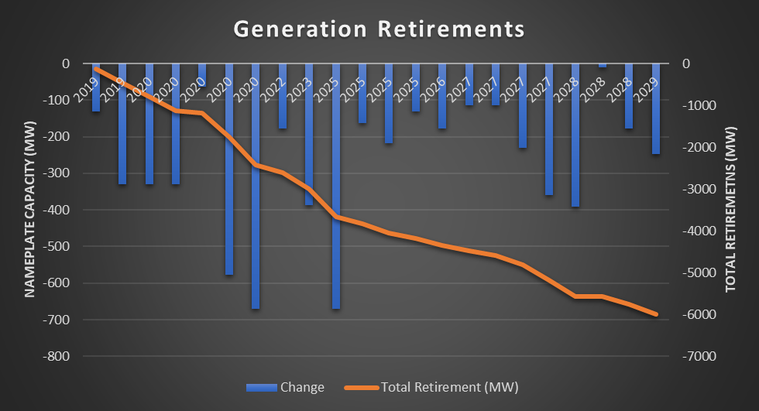

Summary of Key Findings Related to Resource Additions and Retirements
- Significant resource additions and retirements planned in the NG-IM area presenting a shift from baseload dispatchable generation resources to variable generation resources.
- Modeling of the capacity output of these resources for reliability needs to consider wind and solar profiles. The Western Electricity Coordinating Council (WECC) Anchor Data Set (ADS) Production Cost Model (PCM), as described in Section 4.1.7, provides annual wind and solar profiles for modeling the variability associated with these generation resource.
- 1550 MW of energy storage was submitted with most projects located with a renewable resource. These energy storage amounts are shown on the Cumulative Resource Additions Map but are separated in the resource summation for they do not generate energy, but only time shift the delivery of energy to the system.

2.1.4 Transmission Service Obligations
Like loads, resources, and public policy, transmission service obligations may drive transmission development. The NorthernGrid members are encouraged to submit all data that is used in the development of their local transmission plan so that it may be considered during the development of the regional transmission plan. Only one member, IPC, submitted their transmission service reservations as shown in data Table 2.

Data Table 2: Transmission Service Submission
Effective Date | MW | Service Type | POR | POD | Upgrades Required | Additional Info
01/01/26 | 500 | Network | Northwest | IPCO | Yes | IPCO market purchases from the Northwest – summer
01/01/26 | 200 | Network | Northwest | IPCO | Yes | IPCO market purchases from the Northwest – winter
01/01/26 | 250 | Firm | Northwest | BPA SEID | Yes | FCRPS to BPA Southeast Idaho Load - summer
01/02/26 | 550 | Firm | Northwest | BPA SEID | Yes | FCRPS to BPA Southeast Idaho Load - winter

Enrolled Parties Needs
The FERC jurisdictional regional transmission planning tariff requires a summary of enrolled parties data submissions. A summary is provided below based on the requirement of the FERC Order 1000 cost allocation determination of whether proposed projects meet enrolled party needs.

Data Table 3: Enrolled Parties Data Submission Summary
 | 2030 PEAK-LOAD |  |  |  |  | Generation Resources |  |  | Transmission
Member | Winter | Spring | Summer | Fall |  | Additions | Retirements |  | Additions or  Upgrades
AVA | 2325 | 2110 | 2178 | 2090 |  | 0 | 0 |  | 1
IPC | 2903 | 2999 | 4374 | 3287 |  | 155 | 860 |  | 18
NWMT | 2031 | 1816 | 2141 | 1874 |  | 990 | 330 |  | 0
PGE | 3652 | 3371 | 3949 | 3473 |  | 350 | 578 |  | 15
PSE | 5047 | 4363 | 4151 | 4915 |  | 137 | 330 |  | 4
PACE | 7372 | 7244 | 9568 | 7035 |  | 8840 | 1527 |  | 6
PACW | 4013 | 3500 | 3763 | 3642 |  | 2768 | 1160 |  | 0
Enrolled Parties | 27343 | 25401 | 30124 | 26316 |  | 13030 | 4157 |  | 44
Peak Month | 27343 | 24220 | 29771 | 25460

Member Regional Transmission Projects
- Antelope to Goshen 345 kV Transmission Line
- The transmission facilities submitted to NorthernGrid for modeling the UAMPS generation addition near Antelope substation are preliminary in nature as detailed technical studies have not been completed. One of the keys assumptions to the single 345 kV line addition between Antelope and Goshen is that UAMPS has indicated that the proposed generation can be tripped for outage of the Antelope – Goshen 345 kV line. As additional facility modeling details for the UAMPS generation addition are available, PacifiCorp will make necessary updates to the NorthernGrid power flow base case model.
- Boardman to Hemingway Transmission Line Project
- Boardman to Hemingway 500 kV line, Hemingway to Bowmont and Bowmont to Hubbard 230 kV lines.
- Gateway South Transmission Project
- Aeolus to Clover 500 kV Line.
- Gateway West Transmission Project
- Windstar to Aeolus 230 kV line, Anticline to Jim Bridger, Anticline to Populus, Populus to Borah, Populus to Cedar Hill, Cedar Hill to Hemingway, Cedar Hill to Midpoint 500 kV lines and the existing Borah to Midpoint uprate to 500 kV southwestern Nevada (the Crystal-Eldorado 500 kV AC Project).

Figure 10: Member Regional Transmission Projects
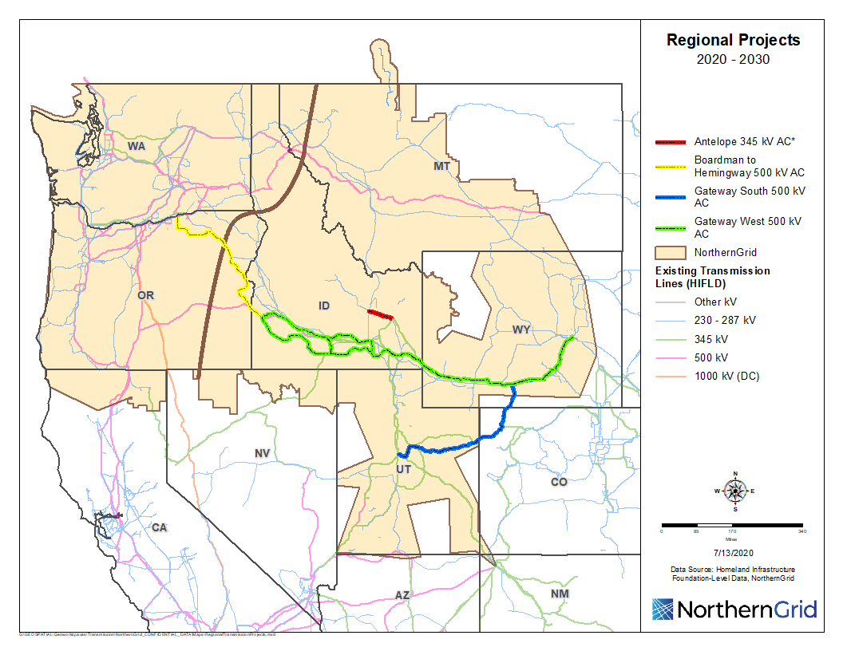

Public Policy Requirements Summary

Approach
NorthernGrid evaluated regional transmission needs driven by public policy requirements by first identifying a list of enacted public policies that impact resource and local transmission plans in the NorthernGrid planning region. This data was procured through the NorthernGrid data submission process and polling of members to inquire about enacted policies that are driving their regional transmission needs. NorthernGrid identified enacted public policies in the seven states within the NorthernGrid region.

Key Assumptions
- Enacted policies include local, state, and federal policies for the NorthernGrid member service area.
- Analysis focuses on enacted policies that address the type of energy portfolio to be delivered. Focus is on staged policies through 2030.
- Non-enacted policies are not included in the analysis.
- Policies pertaining to energy purchases or corporate goals are not included.
- WECC will provide an initial production cost model, but it is the responsibility of the NorthernGrid members to verify.
- Each member’s Integrated Resource Planning process incorporates public policy and the NorthernGrid members evaluate their IRP to determine the data that is submitted.

Key Findings
- There are enacted policies in five of the seven states, including the Renewable Portfolio Standards (RPS) that exist in Washington, California, Oregon, Montana, and Utah.
- There are no identified public policy requirements that are driving regional transmission needs in Wyoming and Idaho.
Please see the appendix for a detailed table of all enacted public policies.

Potential Areas of Regional Coordination
Based on the MPC’s initial review, there are not many opportunities for regional collaboration because the majority of proposed transmission development supports local load service and reliability.

Non-Incumbent Transmission Projects
The NorthernGrid regional planning process allows non-incumbent and merchant transmission developers to submit projects for analysis. Several non-incumbent or merchant transmission projects were received during the submission period. They are further classified into regional and interregional transmission projects based on whether the project terminals are within the region or interconnect between regions, i.e. interregional.

Regional Non-Incumbent
- Cascade Renewable Transmission System
PowerBridge is proposing to construct the Cascade Renewable Transmission System Project. This Project is an 80-mile, 1,100 MW transfer capacity +/- 440 KV HVDC underground cable (95% installed underwater) interconnecting with the grid through two +/- 1100 MW AC/DC converter stations interconnecting with the AC grid at Big Eddy and Troutdale substation. There is no proposed generation resource associated with the transmission line.

- Loco Falls Greenline
Absaroka is proposing a merchant transmission project connecting Great Falls 230 kV substation to the Colstrip 500 kV Transmission System. The project consists of two 230 kV transmission circuits and a new Loco Mountain Substation with 230 to 500 kV transformation. There is no proposed generation resources associated with the transmission line.

Interregional Transmission Projects
As illustrated on Figure 11, there are 3 proposed interregional projects. Summaries of each proposed interregional projects are provided below.
- Cross-Tie Transmission Project
TransCanyon LLC is proposing the Cross-Tie Project, a 1,500 MW, 500 kV single circuit HVAC transmission project that will be constructed between central Utah and east-central Nevada. The project connects PacifiCorp’s planned 500-kV Clover substation (in the NorthernGrid planning region) with NV Energy’s existing 500 kV Robinson Summit substation (in the WestConnect planning region).
Cross-Tie has proposed 9,891 of total cumulative resource additions as a result of the proposed transmission line. These include wind, solar, and natural gas in the states of Wyoming and Utah. Please see the appendix for a data table of proposed generation associated with the Cross-Tie project. The interregional evaluation plan is located at https://www.northerngrid.net/resources/cross-tie-itp-evaluation-plan-2020-21.
- Southwest Intertie Project North (SWIP)
Great Basin Transmission, LLC (“GBT”), an affiliate of LS Power, submitted the 275-mile northern portion of the Southwest Intertie Project (SWIP) to the California ISO and NorthernGrid. SWIP-North was also submitted into WestConnect’s planning process by the Western Energy Connection (WEC), LLC, a subsidiary of LS Power. The SWIP-North Project connects the Midpoint 500 kV substation (in NorthernGrid) to the Robinson Summit 500 kV substation (in WestConnect) with a 500-kV single circuit AC transmission line. The SWIP is expected to have a bi-directional WECC-approved path rating of approximately 2000 MW.
SWIP North has proposed 1,850 MW of new wind generation resources located in Idaho as a result of the transmission line. Please see the appendix for a data table of proposed generation associated with the SWIP North project. The interregional evaluation plan is located at https://www.northerngrid.net/resources/swip-north-itp-evaluation-plan.
- Transwest Express
Transwest Express is a 500 kV DC and 500 kV AC transmission project proposed by TransWest. The TransWest Express (TWE) Transmission Project consists of three discrete interconnected transmission segments that, when considered together, will interconnect transmission infrastructure in Wyoming, Utah, and southern Nevada. TransWest has submitted each of the following TWE Project segments as separate ITP submittals:
- A 405-mile, bi-directional 3,000 MW, ±500 kV, high voltage direct current (HVDC) transmission system with terminals in south-central Wyoming and central Utah (the WY-IPP DC Project).
- A 278-mile 1,500 MW 500 kV alternating current (AC) transmission line with terminals in central Utah and southeastern Nevada (the IPP-Crystal 500 kV AC Project.
- A 50-mile, 1,680 MW 500 kV AC transmission line with terminals in southeastern Nevada, and southwestern Nevada (the Crystal-Eldorado 500 kV AC Project).
There is no proposed new generation associated with the transmission line. The interregional evaluation plan is located at https://www.northerngrid.net/resources/transwest-express-itp-evaluation-plan.

Figure 11: Regional Non-Incumbent and Interregional Transmission Projects
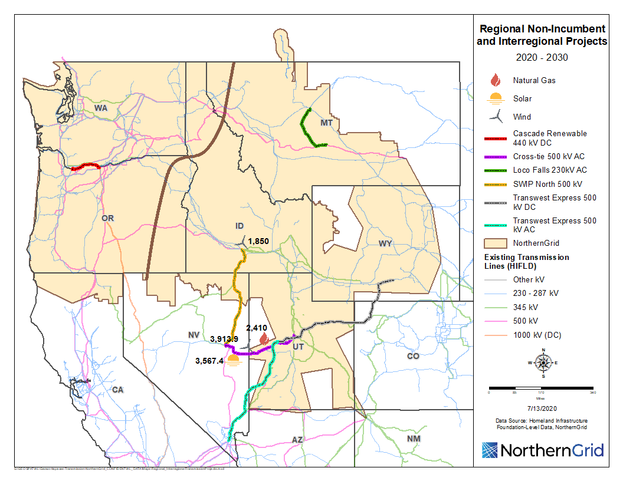

Case Analysis

Methodology and Assumptions Overview
This methodology defines the analysis objectives, conditions (path stressing, power flow direction, imports/exports) necessary to assess the ability of the transmission system to support the 2030 loads and resource, types of analysis, performance criteria, paths to monitor, case checking and tuning (reactive devices, phase shifting transformers) and contingencies. Note, this process is designed to meet Order 890 and 1000 planning requirements and is not intended to evaluate market efficiencies.

Analysis Objectives
Develop the NorthernGrid Regional Transmission Plan by assessing the existing system and committed projects along with combinations of planned and proposed transmission and resource changes for their ability to reliably serve the variations in 2030 loads and resource generation dispatch conditions.

Conditions to Represent
As stated above the NorthernGrid region experiences peak loading conditions during the winter and summer. Therefore, a heavy winter and heavy summer condition will be represented. Additionally, high transmission transfers can occur during the shoulder months. The WECC ADS-PCM will simulate the 2030 transmission power flows for all hours. The NorthernGrid MPC will evaluate flows on the path listed in Appendix B Table B1 and select hours reflecting appropriate transmission stressing conditions for the submitted regional and interregional transmission projects.

WECC Power Flow Cases
The WECC 2030 bases cases provide the representation of the entire western interconnection. Each case’s load and resources will be adjusted based on the member load and resource forecast data submittals. Then the cases will be reviewed against historical BPA path flow data, U.S. Army Corps of Engineers generation loading, Environmental Protection Agency (EPA) thermal plant loading, FERC 714/EIA 930 load data, Member OSIsoft PI SystemTM historian, and other sources, referenced when used, to ensure that the 2030 load, resource, and path loading are credible. Additionally, resource dispatch patterns will be generated through the ADS-PCM and analyzed to select hours that produce transmission stress conditions. These stress conditions will be either exported or modeled (see benchmarking) in power flow cases where the cases may be adjusted further to achieve appropriate stress levels.

WECC Power Flow Cases Summaries
- 2029-30 Heavy Winter 1 - A general ten-year case with typical WECC transmission flows for the expected during MDT hours 1800 through 2000 load peaks occurring in December through February. The resource and transmission representation will be coordinated with the regional planning groups.
- 2030 Light Spring 1-S - Model light-load conditions with solar and wind serving a significant but realistic portion of the WECC total load. The case should only include renewable resource capacity additions that are already planned and included in the 10-year future and represent likely and expected system conditions consistent with any applicable and enacted public policy requirements. Target 60-65% of during MDT hours 1000 through 1400 peak summer loads that would occur during the spring months of March, April, and May. The time of day has been determined from the data gathered from the latest WECC PCM. The model uncovered periods of high renewables when loads were approximately 60-65% of WECC peak. The time was chosen to try and capture solar as well as wind generation.

- 2030 Heavy Summer 1 – A general ten-year case with typical WECC transmission flows for the expected during MDT hours 1500 through 1700 load peaks occurring in June through August.
- 2030 Heavy Summer 1 ADS – An ADS-PCM 7/29/2030 hour 19:00 MDT exported and solved power flow case.

Case Checking and Tuning
The power flow cases will be checked and tuned based on the case checking Table B2 found in Appendix B.

Types of Analysis
- PCM analysis to produce load and generation dispatch patterns for power flow cases.
- Power flow analysis will be performed consistent with NERC Planning Reliability Standard TPL-001 sections applicable to the long-term planning horizon.
- Voltage stability consistent with WECC criteria and transient stability only on the final plan and only for conditions identified in power flow analysis as requiring further study.
- Short circuit and geomagnetic disturbance analysis will not be conducted.

Performance Criteria
The power flow simulations will be monitored for compliance with the North American
Electric Reliability Corporation (NERC) Reliability Standard TPL-001-4 and WECC Criterion TPL-001-WECC-CRT-3.2. The reliability standard requires transmission facilities to operate within normal and emergency limits. Then the criterion further defines the default base planning criteria for steady-state, post-contingency, dip, and recovery voltage along with oscillation dampening. The WECC criterion also allows for transmission planners to apply a more or less stringent criterion for their own system provided they gain agreement or allowance, respectively as described in the criterion. Additional NorthernGrid Member voltage criterion are listed in Table C2 Appendix C.

Contingencies Included
The NorthernGrid regional study focus is to evaluate alternative regional projects for the selection of the NorthernGrid Regional Plan. As such, the contingencies selected need to be relevant to the transmission configurations under evaluation. Therefore, it is prudent to select the contingencies after the study scope is developed and the scenarios selected. The general guideline for contingency analysis is as follows:
- Facilities 230 kV and above that have regional impact. However, this should not limit members or project sponsors from requesting contingency analysis of facilities less than 230 kV if they believe the lower voltage contingency may have a regional impact.
- The category of contingencies analyzed will generally be P1 and P2 if they are critical for evaluating alternatives. The P4 and P5 category contingencies will be included for 300 kV and above. A limited set of P4, P5, and P7 category contingencies that allow interruption of firm transmission service and loss of non-consequential load may be included if a majority of the MPC agree. Additionally, a limited set of P3 and P6, where the requesting entity defines the system adjustments, may be included if a majority of the MPC agree.
- The contingencies submitted should be aux file format that are linked to the selected base case.
- Voltage stability and transient stability contingencies should be selected after the steady state contingency simulations are completed and after discussions and decisions of the need for such analysis. If there is a need to perform stability studies, invitations should go out to members to submit the contingencies with associated Remedial Action Schemes if needed.

Production Cost Model Cases Summary
The 2030 WECC ADS is comprised of data developed by BAs, Transmission Planners and Planning Coordinators in the U.S. and by other entities in Canada and Mexico. The WECC ADS-PCM reflects the load, resource and transmission topology for a ten-year planning horizon. The data reflects applicable state and federal public policy requirements, such as: Renewable Portfolio Standard (RPS), Regional Haze Programs, and Mercury and Air Toxic Standards (MATS). The WECC ADS provides a data set that is intended to be a common starting point for the western interconnection planning analysis. It provides PCM and power flow models, including dynamic data and associated assumptions.

Identification of Other Cases Needed
- 2030 Spring from WECC ADS-PCM export.
- 2030 Fall from WECC ADS-PCM export.

Evaluation of Regional Transmission Project Combinations
To determine whether transmission needs within the NorthernGrid may be satisfied by regional and/or interregional transmission projects, NorthernGrid evaluates the proposed regional and interregional transmission projects independently and in regional combinations. The regional combinations are determined by the MPC based on their knowledge of the NorthernGrid Region. The regional combinations are shown in Table C1 in Appendix C.

Impacts on Neighboring Regions
As stated above, the power flow cases represent the entire western interconnection. Therefore, during the power flow analysis NorthernGrid will monitor for NERC standard and WECC criterion violations occurring in the neighboring regions. Upon identification of a violation in a neighboring region, NorthernGrid will coordinate with the region to confirm validity and whether the violation is due to an existing condition. Mitigation plans for a violation will be determined in accordance with the NorthernGrid Member tariffs and planning agreement.

Cost Allocation

Introduction
Regional project cost allocation is one of the FERC Order 1000 transmission planning reforms. The NorthernGrid FERC jurisdictional entities, the Enrolled Parties, describe the requirements for a project in their OATT Attachment K. The process begins with the sponsor/developer becoming qualified. The following developers submitted information and were determined to be qualified.

Qualified Developers
TransCanyon LLC and Great Basin Transmission, LLC were pre-qualified by NTTG during 2019 for the 2020-21 Regional Transmission Planning cycle. The NorthernGrid Enrolled Parties proposed and FERC accepted that their qualification status be accepted by NorthernGrid during this planning cycle. PowerBridge submitted developer qualification information which was reviewed by the CATF resulting in the approval of PowerBridge as a Qualified Developer for this planning cycle.

Benefits and Beneficiary Analysis
If the sponsored project is selected into the plan as meeting enrolled party or parties need, the project benefits and beneficiaries will be determined. The cost allocation metrics and analysis process is described in each Enrolled Party’s OATT Attachment K – Regional Planning Process.

Appendix A

Data Tables

Data Table A1: Annual Winter and Summer Load Growth Values 2024-2030
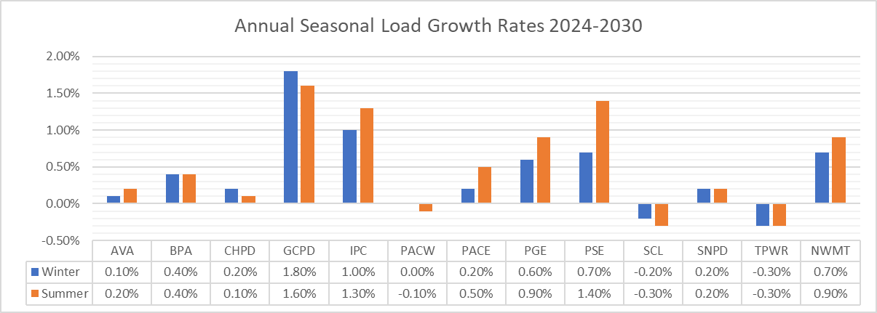

The below maps indicate 2030 summer and winter load distribution in the NorthernGrid Footprint and the colors illustrate high and low load levels.

NorthernGrid footprint – Summer 2030 Loads
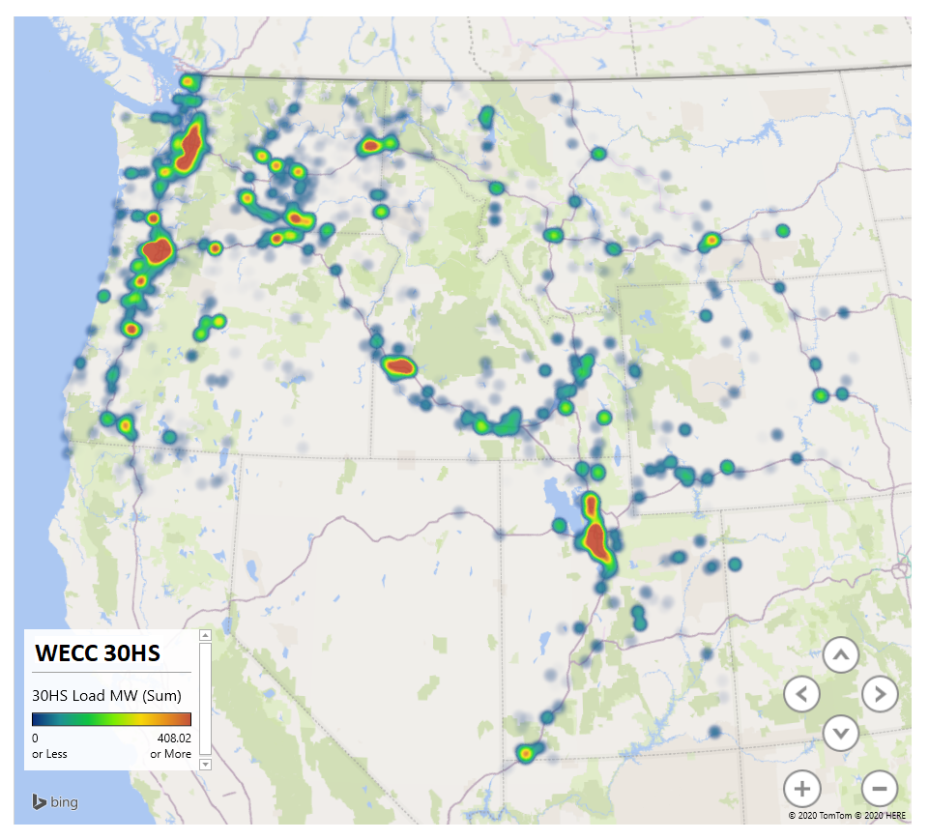
NorthernGrid footprint – Winter 2030 Loads
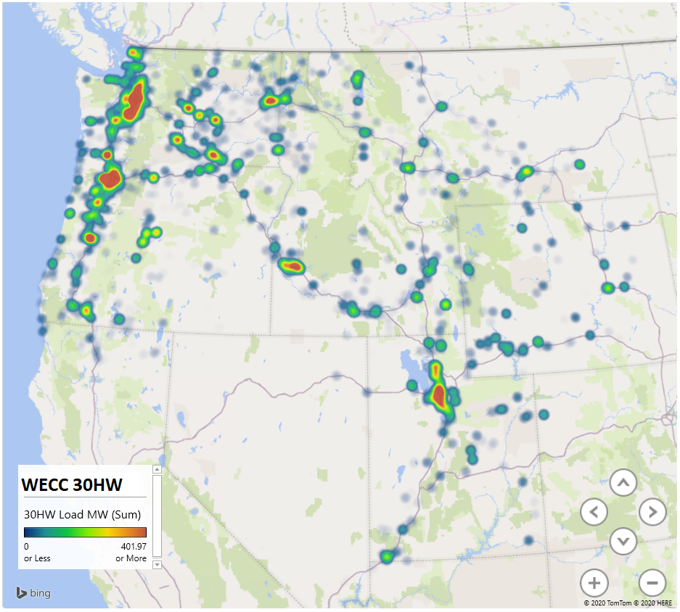

The generation resource additions reflected in Table A2 are preliminary in nature, representative only and are subject to change. Each future resource location modeling is based on current preliminary information that is subject to change. All future resources are based on member resource planning processes. The Enrolled Parties determine resource additions through an IRP process under state mandate. Many of the resource additions presented are based on the existing IRP preferred portfolio which may change during subsequent biennial planning cycles. IRP resource additions are subject to procurement request for proposals which may change the final resource location and in-service date. The values shown are nameplate capacity totals for each resource type by year.

Data Table A2: Cumulative Resource Additions by County
County | State | Year | Projects | Solar | Wind | Natural Gas | Hydro | Wood Waste | Nuclear | Storage
Ada | ID | 2020 | 1 | 0 | 0 | 0 | 2 | 0 | 0 | 0
Apache | AZ | 2022 | 1 | 50 | 0 | 0 | 0 | 0 | 0 | 0
Baker | OR | 2022 | 1 | 3 | 0 | 0 | 0 | 0 | 0 | 0
Beaver | UT | 2020 | 1 | 99 | 0 | 0 | 0 | 0 | 0 | 0
Benton | WA | 2020 | 1 | 0 | 3 | 0 | 0 | 0 | 0 | 0
Carbon | UT | 2020 | 3 | 0 | 750 | 0 | 0 | 0 | 0 | 0
Carbon | UT | 2021 | 1 | 80 | 0 | 0 | 0 | 0 | 0 | 0
Carbon | UT | 2024 | 4 | 0 | 1095 | 0 | 0 | 0 | 0 | 0
Clallam | WA | 2020 | 1 | 0 | 0 | 0 | 0 | 20 | 0 | 0
Converse | WY | 2020 | 3 | 0 | 533 | 0 | 0 | 0 | 0 | 0
Converse | WY | 2021 | 1 | 0 | 201 | 0 | 0 | 0 | 0 | 0
Converse | WY | 2030 | 1 | 0 | 121 | 0 | 0 | 0 | 0 | 0
Converse | WY | 2024 | 1 | 0 | 80 | 0 | 0 | 0 | 0 | 0
Crook | OR | 2020 | 2 | 100 | 0 | 0 | 0 | 0 | 0 | 0
Emery | UT | 2023 | 1 | 20 | 0 | 0 | 0 | 0 | 0 | 0
Emery | UT | 2020 | 1 | 100 | 0 | 0 | 0 | 0 | 0 | 0
Garfield | UT | 2020 | 1 | 1 | 0 | 0 | 0 | 0 | 0 | 0
Hot Springs | WY | 2024 | 1 | 0 | 75 | 0 | 0 | 0 | 0 | 0
Iron | UT | 2024 | 2 | 231 | 0 | 0 | 0 | 0 | 0 | 58
Jackson | OR | 2020 | 1 | 10 | 0 | 0 | 0 | 0 | 0 | 0
Klamath | OR | 2024 | 2 | 500 | 0 | 0 | 0 | 0 | 0 | 335
Laramie | WY | 2024 | 2 | 0 | 317 | 0 | 0 | 0 | 0 | 0
Lewis | WA | 2020 | 1 | 0 | 137 | 0 | 0 | 0 | 0 | 0
Lincoln | WY | 2020 | 1 | 0 | 161 | 0 | 0 | 0 | 0 | 0
Lincoln | WY | 2026 | 1 | 0 | 0 | 185 | 0 | 0 | 0 | 0
Lincoln | WY | 2026 | 1 | 0 | 0 | 370 | 0 | 0 | 0 | 0
Linn | OR | 2028 | 1 | 0 | 0 | 0 | 0 | 0 | 0 | 85
Marion | OR | 2029 | 1 | 0 | 0 | 0 | 0 | 0 | 0 | 45
Morrow | OR | 2020 | 1 | 0 | 300 | 0 | 0 | 0 | 0 | 0
Morrow | OR | 2021 | 1 | 50 | 0 | 0 | 0 | 0 | 0 | 0
Multnomah | OR | 2029 | 1 | 0 | 0 | 0 | 0 | 0 | 0 | 105
Natrona | WY | 2024 | 2 | 0 | 353 | 0 | 0 | 0 | 0 | 0
Rosebud and Custer | MT | 2021 | 1 | 0 | 750 | 0 | 0 | 0 | 0 | 0
Salt Lake | UT | 2021 | 2 | 159 | 0 | 0 | 0 | 0 | 0 | 40
Salt Lake | UT | 2030 | 1 | 0 | 1040 | 0 | 0 | 0 | 0 | 0
Salt Lake | UT | 3031 | 1 | 0 | 0 | 0 | 0 | 0 | 0 | 40
Savier | UT | 2020 | 1 | 80 | 0 | 0 | 0 | 0 | 0 | 0
Savier | UT | 2030 | 2 | 500 | 0 | 0 | 0 | 0 | 0 | 125
Stillwater | MT | 2021 | 1 |  | 80 | 0 | 0 | 0 | 0 | 80
Stillwater | MT | 2021 | 1 |  | 80 | 0 | 0 | 0 | 0 | 80
Sweetwater | WY | 2024 | 2 | 354 | 0 | 0 | 0 | 0 | 0 | 88.5
Thurston | WA | 2020 | 1 | 0 | 136.8 | 0 | 0 | 0 | 0 | 0
Tooele | UT | 2023 | 2 | 3 | 0 | 0 | 0 | 0 | 0 | 1
Twin Falls | ID | 2020 | 1 | 0 | 0 | 0 | 2 | 0 | 0 | 0
Twin Falls | ID | 2022 | 1 | 120 | 0 | 0 | 0 | 0 | 0 | 0
Umatilla | OR | 2020 | 2 | 0 | 20 | 0 | 0 | 0 | 0 | 0
Utah | UT | 2020 | 1 | 50 | 0 | 0 | 0 | 0 | 0 | 0
Utah | UT | 2022 | 2 | 64 | 0 | 0 | 0 | 0 | 0 | 16
Utah | UT | 2023 | 2 | 30 | 69 | 0 | 0 | 0 | 0 | 0
Benton | ID | 2027 | 1 | 0 | 0 | 0 | 0 | 0 | 720 | 0
Walla Walla | WA | 2029 | 1 | 0 | 0 | 0 | 0 | 0 | 0 | 75
Washington | UT | 2020 | 2 | 180 | 0 | 0 | 0 | 0 | 0 | 0
Weber | UT | 2024 | 2 | 674 | 0 | 0 | 0 | 0 | 0 | 168
Yakima | WA | 2024 | 2 | 395.2 | 0 | 0 | 0 | 0 | 0 | 98.8
Yakima | WA | 2028 | 1 | 0 | 0 | 0 | 0 | 0 | 0 | 105
Yakima | WA | 2029 | 2 | 0 | 9.8 | 0 | 0 | 0 | 0 | 2.45

Data Table A3: Cumulative Resource Retirements by County
Power Plant | Unit | Retirement Year | Capacity | Notes
Valmy (IPC Share) | 1 | 2019 | 131 | Year end
Naughton | 3 | 2019 | 329 | Natural Gas Repower
Colstrip (PSE share) | 1 | 2020 | 115 | January 2nd
Colstrip (NWMT – Talon share) | 1 | 2020 | 115 | January 2nd
Colstrip (PSE Share) | 2 | 2020 | 115 | January 3rd
Colstrip (NWMT - Talon share) | 2 | 2020 | 115 | January 3rd
Boardman (IPC Share) | 1 | 2020 | 64 | Year end
Boardman | 1 | 2020 | 578 | Year end
Centralia | 1 | 2020 | 670 | Year end
Jim Bridger (IPC Share) | 1 | 2022 | 178 | Year end
Jim Bridger (PAC Share) | 1 | 2023 | 386 | Year end
Centralia | 2 | 2025 | 670 | Year end
Naughton | 1 | 2025 | 163 | Year end
Naughton | 2 | 2025 | 218 | Year end
Valmy (IPC Share) | 2 | 2025 | 131 | Year end
Jim Bridger (IPC Share) | 2 | 2026 | 178 | Year end
Dave Johnston | 1 | 2027 | 114 | Year end
Dave Johnston | 2 | 2027 | 114 | Year end
Dave Johnston | 3 | 2027 | 230 | Year end
Dave Johnston | 4 | 2027 | 360 | Year end
Jim Bridger (PAC Share) | 2 | 2028 | 391 | Year end
Orem Family Wind, LLC | all | 2028 | 10
Bridger (IPC Share) | 3 | 2028 | 178 | Year end
Naughton | 3 | 2029 | 247 | Natural Gas
Total Retirements 2020 to 2030 |  |  | 6000

Data Table A4: Enacted Public Policies
Enacted Public Policy | Bill History | Description
Washington Clean Energy Transformation Act (CETA) | Initiative Measure 937 (2006)  SB 5400 (2013)  SB 5116 (2019) | CETA requires the state's electric utilities to fully transition to clean, renewable and non-emitting resources by 2045. The act sets the following mandatory targets:  - 2025 – All electric utilities must eliminate coal-fired generation serving Washington state customers.  - 2030 – All electric utilities must be greenhouse gas neutral—for example, remaining carbon emissions are offset by renewable energy, energy efficiency, carbon reduction project investments, or payments funding low-income assistance.  - 2045 – All electric utilities must generate 100% of their power from renewable or zero-carbon resources.  RPS Targets:  - 3% by January 1, 2012  - 9% by January 1, 2016  - 15% by January 1, 2020 and beyond  *Annual targets are based on the average of the utility’s loads for the previous two years
Montana RPS | SB 415 (2005) – “Montana Renewable Power Production and Rural Economic Development Act”  SB 325 (2013)  SB 45 (2013) | Montana’s renewable portfolio standard (RPS), enacted in April 2005 as part of the Montana Renewable Power Production and Rural Economic Development Act, requires public utilities and competitive electricity suppliers serving 50 or more customers to obtain a percentage of their retail electricity sales from eligible renewable resources according to the following schedule:  - 5% for compliance years 2008-2009  - 10% for compliance years 2010-2014  - 15% for compliance year 2015 and for each year thereafter  Two bills in 2013 expanded the RPS to include additional types of projects. SB 325 allows wood pieces that have been treated with chemical preservatives, and that are used at a facility that has a nameplate capacity of 5 MW or less, to qualify. SB 45 allows expansions to existing hydroelectric projects that result in increased generation capacity to qualify.  Public utilities of Montana shall proportionately allocate the purchase of both the renewable energy credits and the electricity output from community renewable energy projects that total at least 75 megawatts in nameplate capacity for any given compliance year based on the public utility's previous year's sales of electrical energy to retail customers in Montana.
California RPS | SB 1078 (2002)  Assembly Bill 200 (2005)  SB 107 (2006)  SB 2 First Extraordinary Session (2011)  SB 350 (2015)  SB 100 (2018) | California's RPS Program Interim Targets:  - 20% by December 31, 2013  - 25% by December 31, 2016  - 33% by December 31, 2020  - 44% by December 31, 2024  - 52% by December 31, 2027  - 60% by December 31, 2030 and beyond  - Planning target of 100% renewable and carbon-free by 2045  *Based on the retail load for a three-year compliance period
Oregon RPS | SB 838 (2007)  BH 3039 (2009)  HB 1547-B (2016) | On March 8, 2016, Governor Kate Brown signed Senate Bill 1547-B (SB 1547-B), the Clean Electricity and Coal Transition Plan, into law. The bill extends and expands the Oregon RPS requirement to 50 percent of electricity from renewable resources by 2040 and requires that coal-fired resources are eliminated from Oregon’s allocation of electricity by January 1, 2030.  The increase in the RPS requirements is staged:  - 5% by December 31, 2011  - 15% by December 31, 2015  - 20% by December 31, 2020  - 27% by December 31, 2025  - 35% by December 31, 2030  - 45% by December 31, 2035  - 50% by December 31, 2040  *Based on the retail load for that year.
Utah RPS | SB 202 (2008) | Goal of 20% by 2025 (must be cost effective)  *Annual targets are based on the adjusted retail sales for the calendar year 36 months before the target year.
Idaho | N/A | No applicable enacted policies
Wyoming | N/A | No applicable enacted policies

Data Table A5: NorthernGrid Member Projected Transmission
Company | Project Name | Voltage (kV) | Expected In-Service Year | Status | Primary Driver
AVA | Saddle Mountain Substation | 230/115 | 2021 | Under Construction | Reliability & Capacity
BPA | St. Clair - South Tacoma 230 kV Line Upgrade | 230 | 2022 | replacement in 2022 | Firm transmission service to replace Centralia unit 1 power
BPA | Monroe-Novelty 230 kV Line Upgrade | 230 | 2022 | Planned | This project improves reliability for the Puget Sound load area.
SnoPUD | Swamp Creek Switching Station | 115 | 2020 | Unknown | Capacity Need
SnoPUD | Stanwood-Camano Projects | 115 | 2023 | Unknown | Load Service Project
SnoPUD | Sky Valley - Maltby Line | 115 | 2025 | Unknown | Load Service Project
SnoPUD | Getchell Switching Station | 115 | 2024 | Unknown | Capacity Need
SnoPUD | Port of Everett Switching Station | 115 | 2025 | Unknown | Operational Flexibility/Distribution Capacity
SnoPUD | Beverly to Boeing | 115 | 2025 | Unknown | Capacity Need
IPCO | Boardman-Hemingway (B2H) Project | 500 | 2026 | Conceptual | Load Service and TSR Obligations
IPCO | Hemingway-Bowmont | 230 | 2026 | Conceptual | B2H Integration
IPCO | Bowmont-Hubbard | 230 | 2026 | Conceptual | B2H Integration
IPCO | Midpoint to Hemingway #2 | 500 | 2024 | Conceptual | Congestion, Reliability
IPCO | Cedar Hill to Hemingway | 500 | 2024 | Conceptual | Congestion, Reliability
IPCO | Cedar Hill to Midpoint | 500 | 2024 | Conceptual | Congestion, Reliability
IPCO | Midpoint to Borah | 500 | 2024 | Conceptual | Congestion, Reliability
IPCO | Borah – Kinport | 345 | 2024 | Conceptual | Congestion, Reliability
IPCO | Borah - Populus | 500 | 2024 | Conceptual | Congestion, Reliability
IPCO | Populus – Cedar Hill | 500 | 2024 | Conceptual | Congestion, Reliability
IPCO | Willis-Lansing | 138 | 2019 | Completed | Load Service and TSR Obligations
IPCO | Boise Bench - Cloverdale | 230 | 2020 | Under Construction | B2H Integration
IPCO | Cloverdale-Locust | 230 | 2020 | Under Construction | B2H Integration
IPCO | Beacon Light 138kV | 138 | 2020 | Under Construction | Congestion, Reliability
IPCO | Can Ada – Blackcat | 138 | 2020 | Under Construction | Congestion, Reliability
IPCO | Cloverdale-Hubbard | 230 | 2021 | Planned | Congestion, Reliability
IPCO | Wood River-Ketchum Transmission | 138 | 2021 | Delayed - Siting Challenges | Congestion, Reliability
IPCO | Orchard | 138 | 2022 | Planned | Congestion, Reliability
PACE | Segment D.1 - Windstar to Aeolus | 230 | 2023 | Planned | Transmission service request queues, increased system reliability and integrating resources development.
PACE | Segment D.2 - Aeolus to Bridger/Anticline | 500 | 2020 | Planned | Transmission service request queues, increased system reliability and integrating resources development.
PACE | Segment D.3 - Bridger/Anticline to Populus | 500 | 2024 | Planned | Transmission service request queues, increased system reliability and integrating resources development.
PACE | Segment E –Populus to Midpoint | 500 | 2024 | Planned | Transmission service request queues, increased system reliability and integrating resources development.
PACE | Segment E.2 - Midpoint/Cedar Hill to Hemingway | 500 | 2024 | Planned | Transmission service request queues, increased system reliability and integrating resources development.
PACE | Gateway South Transmission Project Segment F - Aeolus-Mona | 500 | 2023 | Planned | Delivery of network resources to network load. Load growth requirements.
PGE | Blue Lake Phase II | 230 | 2020 | Under Construction | Reliability
PGE | Brookwood Substation | 115 | 2021 | Planned | Reliability
PGE | Butler Substation | 115 | 2022 | Under Construction | Reliability
PGE | Canyon-Urban 115 kV Reconductor | 115 | 2022 | Planned | Reliability
PGE | Century Substation | 115 | 2023 | Planned | Reliability
PGE | Evergreen Substation | 230 | 2024 | Planned | Reliability
PGE | Harborton Reliability Project | 230 | 2026 | Under Construction | Reliability
PGE | Helvetia Substation | 115 | 2021 | Planned | Reliability
PGE | Main Substation | 115 | 2023 | Planned | Reliability
PGE | Mt Pleasant Substation | 115 | 2023 | Planned | Reliability
PGE | Murrayhill-St Marys 230 kV Reconductor | 230 | 2022 | Planned | Reliability
PGE | Rock Creek Substation | 115 | 2021 | Under Construction | Reliability
PGE | Roseway substation | 115 | 2020 | Under Construction | Reliability
PGE | SE Portland Conversion | 115 | 2027 | Planned | Reliability
PGE | Tonquin Substation | 115 | 2025 | Planned | Reliability
PSEI | West Kitsap | 115 | 2029 |  | Reliability
PSEI | Energize Eastside | 230 | 2022 |  | Reliability
PSEI | Energize Eastside | 230 | 2022 |  | Reliability
PSEI | Sedro-Bellingham #4115-kV | 115 | 2021 |  | Reliability
SCL | Denny Phase 2 | 115 | 2022 | Conceptual | Reliability
GCPUD | Wanapum – Mountain View 230 kV line | 230 | 2026 | Planned | Quincy load growth from data servers

Data Table 7: Regional Non-Incumbent and Interregional Transmission Projects Generation Additions
Project | Fuel Type | Nameplate Capacity | State | County
Cross-Tie | Wind | 237 | WY | Carbon
Cross-Tie | Wind | 230 | WY | Carbon
Cross-Tie | Wind | 250 | WY | Carbon
Cross-Tie | Wind | 250 | WY | Carbon
Cross-Tie | Wind | 250 | WY | Carbon
Cross-Tie | Wind | 750 | WY | Converse
Cross-Tie | Wind | 350 | WY | Converse
Cross-Tie | Wind | 120 | WY | Uinta
Cross-Tie | Wind | 280 | WY | Albany
Cross-Tie | Solar | 80 | WY | Sweetwater
Cross-Tie | Solar | 30 | WY | Natrona
Cross-Tie | Solar | 80 | WY | Natrona
Cross-Tie | Wind | 100 | WY | Natrona
Cross-Tie | Solar | 74.9 | WY | Fremont
Cross-Tie | Solar | 80 | WY | Natrona
Cross-Tie | Solar | 80 | WY | Natrona
Cross-Tie | Wind | 75.9 | WY | Carbon
Cross-Tie | Wind | 101 | WY | Uinta
Cross-Tie | Wind | 200 | WY | Carbon
Cross-Tie | Wind | 400 | WY | Carbon
Cross-Tie | Wind | 80 | WY | Albany
Cross-Tie | Wind | 80 | WY | Albany
Cross-Tie | Wind | 80 | WY | Albany
Cross-Tie | Wind | 80 | WY | Albany
Cross-Tie | Natural Gas | 200 | UT | SaltLake
Cross-Tie | Natural Gas | 280 | UT | Juab
Cross-Tie | Natural Gas | 245 | UT | Juab
Cross-Tie | Natural Gas | 535 | UT | Utah
Cross-Tie | Natural Gas | 625 | UT | Utah
Cross-Tie | Natural Gas | 525 | UT | Sevier
Cross-Tie | Solar | 204 | UT | Kane
Cross-Tie | Solar | 200 | UT | Iron
Cross-Tie | Solar | 525 | UT | Iron
Cross-Tie | Solar | 187.5 | UT | Iron
Cross-Tie | Solar | 200 | UT | Emery
Cross-Tie | Solar | 200 | UT | Emery
Cross-Tie | Solar | 200 | UT | Emery
Cross-Tie | Solar | 136 | UT | Kane
Cross-Tie | Solar | 240 | UT | San Juan
Cross-Tie | Solar | 525 | UT | Tooele
Cross-Tie | Solar | 525 | UT | Utah
TOTAL |  | 9891.3
SWIP North | Wind | 1050.00 | ID | Lincoln, Jerome, Minidoka
SWIP North | Wind | 800.00 | ID | Twin Falls
TOTAL |  | 1850.00

Appendix B

Table B1. Paths to Monitor
Path Number | Path Name | Reason
 | West of McNary | B2H East to West Flow
 | West of Slat | B2H East to West Flow
 | West of John Day | B2H East to West Flow
3 | Northwest to British Columbia
4 | West of Cascades – North
5 | West of Cascades - South | Cascade Renewable Transmission
6 | West of Hatwai
8 | Montana to Northwest | Loco Falls Greenline
14 | Idaho to Northwest | B2H Bi-directional
16 | Idaho-Sierra | TWE
17 | Borah West | Gateway West
19 | Bridger West | TWE
20 | Path C | TWE
27 | IPP - DC Line | TWE
28 | Mona – IPP | TWE
30 | TOT 1A | TWE
31 | TOT 2A | TWE
32 | Pavant-Gondor/IPP – Gonder | TWE
35 | TOT 2C | TWE
65 | California Oregon Intertie (COI) | B2H West to East Flow
66 | Pacific DC Intertie (PDCI) | B2H West to East Flow
71 | South of Allston | Cascade Renewable Transmission
73 | North of John Day | Cascade Renewable Transmission
75 | Hemingway –Summer Lake | B2H Bi-directional
78 | TOT 2B1 | TWE
79 | TOT 2B2 | TWE
80 | Montana Southwest | Loco Falls Greenline
83 | Montana Alberta Tie Line | Loco Falls Greenline
 | Midpoint West - III-7 | B2H, SWIP-N, Gateway West
 | Populus West | Gateway West
 | Aeolus West - III-3 | TWE
 | Aeolus South – III-2 | TWE

Table B2. Case Checking and Tuning
Use it as a checklist when reviewing a case.
General
¨ | Check for WECC base case modifications applied
¨ | Review general high-level modeling objectives met within (5-10%) – target path flows, etc.
¨ | Check that intended projects and user-submitted corrections / changes applied
Paths
¨ | Check that path elements are defined correctly
¨ | Check that path limits are appropriate
Voltage / VARs
¨ | Review voltage profiles / reactive resource usage
¨ | Check bus voltages against voltage schedules
¨ | Review for parallel transformers circulating VARs
¨ | Review series capacitor status
Generation
¨ | Review gen units online with unusually low or high MW or MVAr levels
¨ | Review generators without reactive capability curves and with large MVAr limits
¨ | Review area reserve factors for adequacy
Load
¨ | Review loads with unusual power factors
¨ | Review unusual load levels (>5% difference than historic forecasts)
Branches
¨ | Check for base case high facility loading or overloads
¨ | Check for seasonal normal-opens applied
¨ | Review unusual impedance X/R ratios
¨ | Check limits to ensure normal is less than or equal to emergency rating
¨ | Check limits to ensure summer <= spring/fall <= winter ratings
Other
¨ | Auto-generate geo mapping of case facility latitude/longitude to review connectivity
¨ | Review PDCI/IPP firing angles not at or near limits
¨ | Review proper modeling of line relays on multi-section lines and 3-terminal transformers for stability simulations
¨ | Check Grand Coulee is not used as the swing unit in contingency analysis and distribute generation make-up across the region
¨ | Check appropriate limits for thermal / voltage applied and set in contingency analysis
¨ | Check Balancing Authority data mapping
Check = look at data for abnormal conditions or to ensure actions have been taken
Review = understand the general data set and look into outlying conditions

Appendix C

Table C1. Regional Combinations
Case | B2H [H] | Gateway West  (Pop - Ced- Hem) [E] | Gateway West  (Pop - Bor - Mid - Hem) [E] | Gateway West  (Mid - Ced) | Gateway West  (Ant - Pop) [D.3] | Antelope | Gateway South [F] | SWIP-N | Cross-Tie | TransWest Express DC | TransWest Express DC/AC | Loco Falls Greenline | Cascade Renewable Transmission
2030 ADS*
BLMP** | x | x | x | X | x | x | x
RC1*** | x |  |  |  |  | x
RC2 | x |  |  |  |  | x | x
RC3 | x | x |  |  | x | x | x
RC4 | x | x |  | x | x | x | x
RC5 | x |  | x |  | x | x | x
RC6 | x | x |  |  | x | x
RC7 | x | x |  | x | x | x
RC8 | x |  | x |  | x | x
RC9 |  |  |  |  |  | x | x
RC10 |  | x |  |  | x | x | x
RC11 |  | x |  | x | x | x | x
RC12 |  |  | x |  | x | x | x
RC13 |  | x |  |  | x | x
RC14 |  | x |  | x | x | x
RC15 |  |  | x |  | x | x
RC16 |  |  |  |  |  | x |  | x
RC17 |  | x |  |  | x | x | x | x
RC18 | x | x |  |  | x | x |  | x
RC19 | x |  |  |  |  | x | x | x
RC20 | x | x |  |  |  | x | x | x
RC21 | x |  |  |  | x | x | x | x
RC22 |  |  |  |  |  | x |  |  | x
RC23 |  | x |  |  | x | x | x |  | x
RC24 | x | x |  |  | x | x |  |  | x
RC25 | x |  |  |  |  | x | x |  | x
RC26 | x | x |  |  |  | x | x |  | x
RC27 | x |  |  |  | x | x | x |  | x
RC28 |  |  |  |  |  | x |  |  |  | x
RC29 |  | x |  |  | x | x | x |  |  | x
RC30 | x | x |  |  | x | x |  |  |  | x
RC31 | x |  |  |  |  | x | x |  |  | x
RC32 | x | x |  |  |  | x | x |  |  | x
RC33 | x |  |  |  | x | x | x |  |  | x
RC34 |  |  |  |  |  | x |  |  |  |  | x
RC35 |  | x |  |  | x | x | x |  |  |  | x
RC36 | x | x |  |  | x | x |  |  |  |  | x
RC37 | x |  |  |  |  | x | x |  |  |  | x
RC38 | x | x |  |  |  | x | x |  |  |  | x
RC39 | x |  |  |  | x | x | x |  |  |  | x
RC40 |  |  |  |  |  | x |  |  |  |  |  | x
RC41 |  | x |  |  | x | x | x |  |  |  |  | x
RC42 | x | x |  |  | x | x |  |  |  |  |  | x
RC43 | x |  |  |  |  | x | x |  |  |  |  | x
RC44 | x | x |  |  |  | x | x |  |  |  |  | x
RC45 | x |  |  |  | x | x | x |  |  |  |  | x
RC46 |  |  |  |  |  | x |  |  |  |  |  |  | x
RC47 |  | x |  |  | x | x | x |  |  |  |  |  | x
RC48 | x | x |  |  | x | x |  |  |  |  |  |  | x
RC49 | x |  |  |  |  | x | x |  |  |  |  |  | x
RC50 | x | x |  |  |  | x | x |  |  |  |  |  | x
RC51 | x |  |  |  | x | x | x |  |  |  |  |  | x
* WECC ADS Case
** Baseline Member Projects
*** Regional Combination 1

Table C2. Member Voltage Criteria
Entity | Facility Classification | System Normal P0 (percent) | Post Contingency P1 Events (percent) | Post Contingency P2-P7 Events (percent)
BPA | Main Grid 500 kV | 105-110 | 100-110 | 100-110
BPA | Main Grid <500 kV | 100-105 | 95-105 | 95-105
BPA | Secondary Grid | 100-105 | 95-105 | 95-105
BPA | Lower Voltage Network | 100-105 | 95-105 | 95-105
CHPD | Transmission | 95-105 | 90-105 | 90-105
CHPD | Generation | 95-106 | 95-105 | 95-105
NWMT | 230 and 161 kV | 95-105 | 95-105 | 93-105
NWMT | 115 and 100 kV | 95-105 | 93-105 | 90-105
NWMT | 69 and 50 kV | 93-105 | 93-105 | 90-105

These first three case descriptions are derived from the 2019 base case compilation schedule case descriptions. https://www.wecc.org/Administrative/2019%20Base%20Case%20Compilation%20Schedule.pdf

