
Member Committee (MPC) Meeting – January 20, 2026
Minutes captured by Chelsea Loomis

Agenda
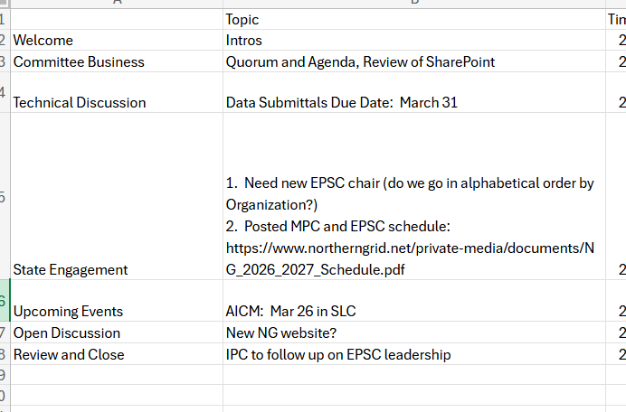

Committee Business
Quorum was established and SharePoint features and main file locations were reviewed.

Technical Discussion
A reminder that all data submittals are due March 31, 2026 for the 2026-2027 NG Planning Cycle

State Engagement
Discussion of who would be the new EPSC Co-Chair from the Enrolled Parties. Idaho was nominated. The EPSC will meet the last Wednesday of every Quarter.

Upcoming Events
The AICM is scheduled for Thursday, March 26 in SLC.

Open Discussion
Idaho committed to following up on the possibility of offering up the EPSC Co-chair position.

Review and Close

