
Members Planning Committee (MPC) Meeting – May 18, 2022
Minutes captured by Scott Beyer, WPP

Introductions
Quorum established – 13 parties represented. MPC Chair Zach Zornes kicked off the meeting and ran through the April meeting minutes. April meeting minutes approved by consensus

Study Scope Update and Next Steps
Study Scope Development Team (SSDT) has been working to identify system stressed conditions for study. Draft study scope is available on SharePoint for MPC with goal to refine draft and make available to larger stakeholder committee by June 6. Following posting of study scope, provide 7-day notice for June 13 meeting to review study scope. Goal to have final study scope approved by MPC vote by July 20, 2022:
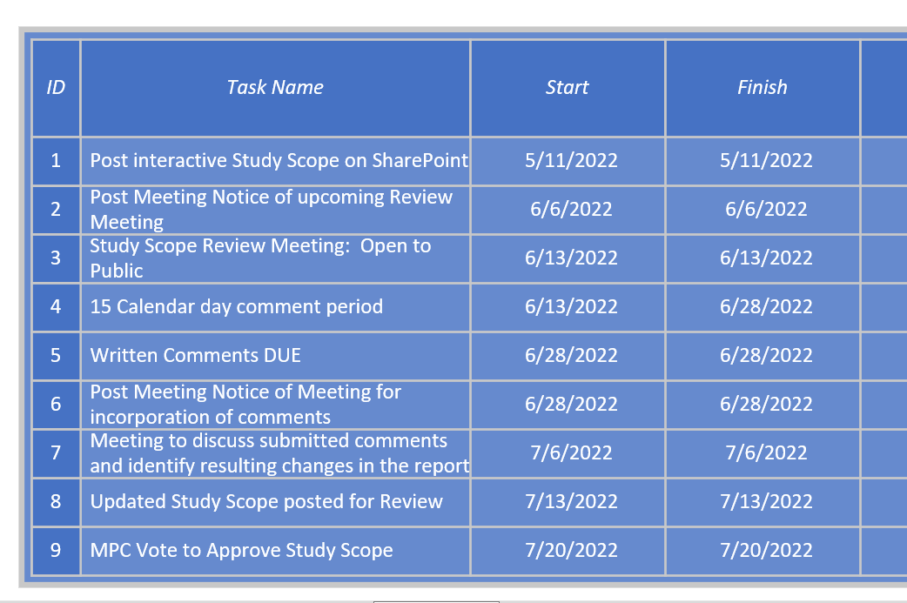

Economic Study Request Discussion
Two Economic Study Requests (ESRs) were received during the request submittal period. The SSDT reviewed the requests and determined that both requests met the requirements to be considered as valid requests. The tariff requires evaluation of one ESR study, without additional cost to the requestor, per calendar year. The SSDT performed a straw poll and the Oregon off-shore wind ESR received a larger number of votes than the Wyoming pumped storage ESR.
The SSDT also determined that the Oregon off-shore wind request would need to include both power flow and production cost modeling whereas the Wyoming pumped storage request would only require production cost modeling.
Zach requested robust input on the two requests from MPC members, followed by a straw poll or formal vote today if possible.

Economic Study Requests: Discussion and Vote
PGE expressed support for the off-shore wind study due to a lack of adequate assessment of transmission impacts in existing studies on off-shore wind potential in Oregon. Additional discussion from MPC members on ensuring the scope of either study request be limited to optimize value of assessment against cost of study. Multiple members expressed support for SSDT recommendation that if Oregon off-shore wind ESR is selected, only one generation level be evaluated. The request submitter asked that if only one level is evaluated, the 3 GW of new off-shore wind request be selected.
The Enrolled Parties voted to accept the Oregon off-shore wind ESR at a 3 GW study level as the calendar year 2022 request by unanimous vote: 7 members for, 0 against and 0 abstained.

Open Discussion
None

Decisions:
The Enrolled Parties voted to accept the Oregon off-shore wind ESR at a 3 GW study level as the calendar year 2022 request by unanimous vote: 7 members for, 0 against and 0 abstained.

Actions:
Action Item: WPP Staff to work with Paul Nguyen and Berhanu Tesema on SharePoint access.

Representatives:

NorthernGrid Member Attendance
Member | Representative | Y | Alternate | Y | Count
Avista | John Gross | 0 | April Spacek | 1 | 1
BPA | Berhanu Tesema | 1 | Paul Nguyen | 0 | 1
Chelan | Zach Zornes | 1 | Steve Wickel | 0 | 1
MATL | Sharmen Andrew | 0 | Ani Chopra | 1 | 1
Grant | Tracy Rolstad | 0 | May Le | 0
IPC | Curtis Westhoff | 0 | Stephen Longmuir | 1 | 1
NV Energy | Alex Ford | 1 | Charles Pottey | 1 | 1
NorthWestern | Matt Stajcar | 1 | Kim McClafferty | 1 | 1
PAC | Rikin Shah | 1 | Kishore Patel | 1 | 1
PGE | Ian Beil | 1 | Chris Kulink | 0 | 1
PSE | Erik Olson | 1 | Emily Hnatishin |  | 1
SCL | Desmond Chan | 0 | Rob Jones | 1 | 1
Sno PUD | Ken Che | 1 | John Martinsen | 0 | 1
Tacoma | Khanh Thai | 0 | Megan Cammarano | 1 | 1
EPSC Enrolled Party Chair | Graham Retzlaff | 1 |  | 0 | 1
EPSC State Chair |  | 0 |  | 0
 |  |  | Quorum | Y | 14

